How to install Music Web

Music Web On Website

1. Open file MuzikWeb.sql in db folder

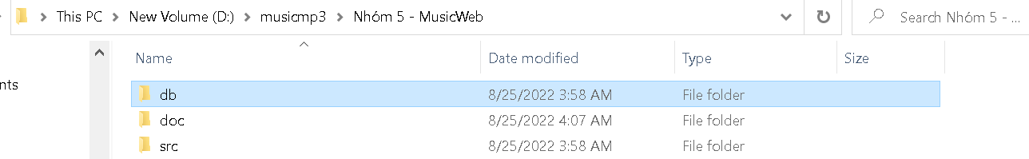

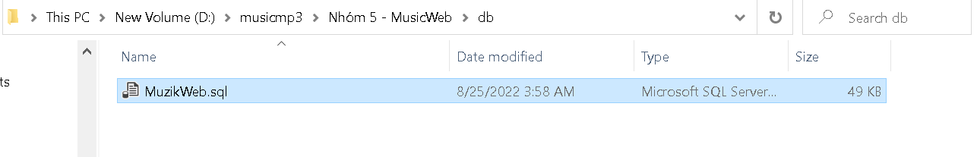

1. Create Database MusicStore

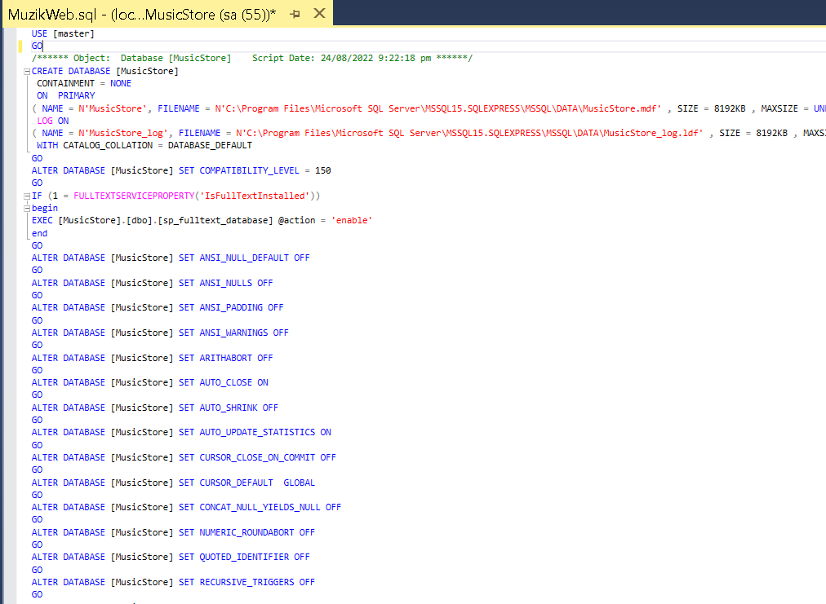

3.Open NetBeans

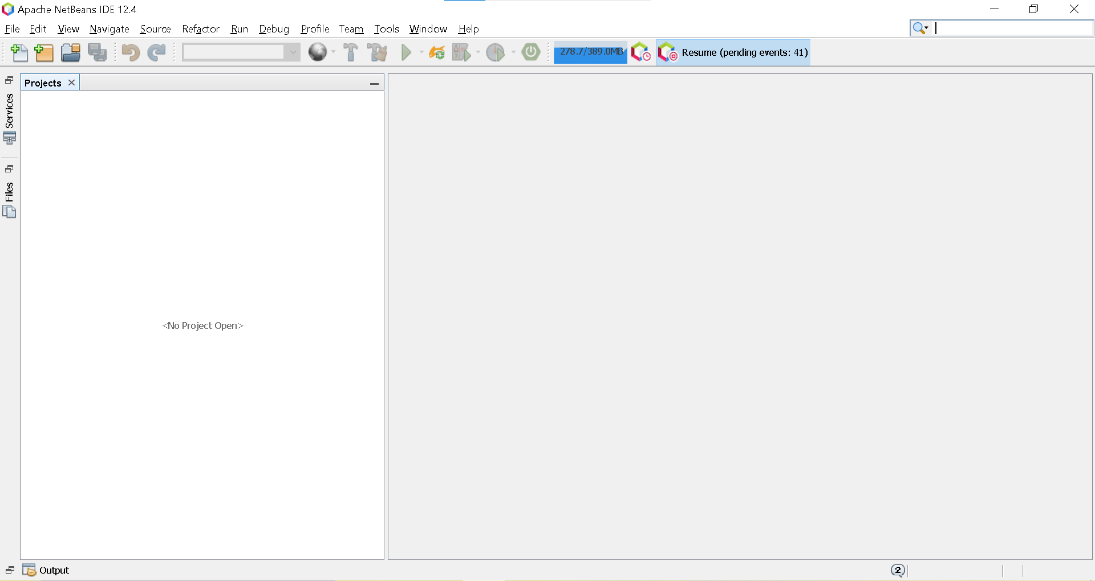

4.Open Project in folder src

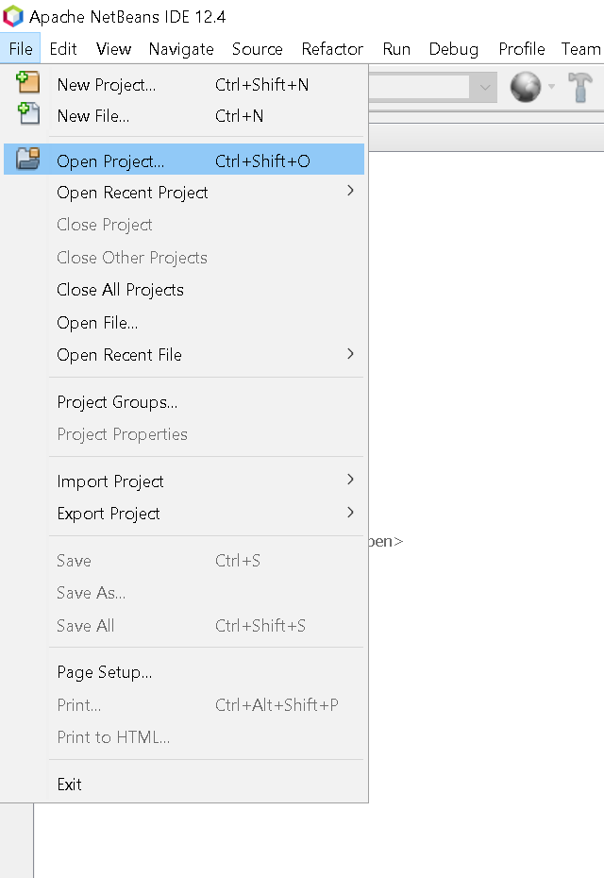

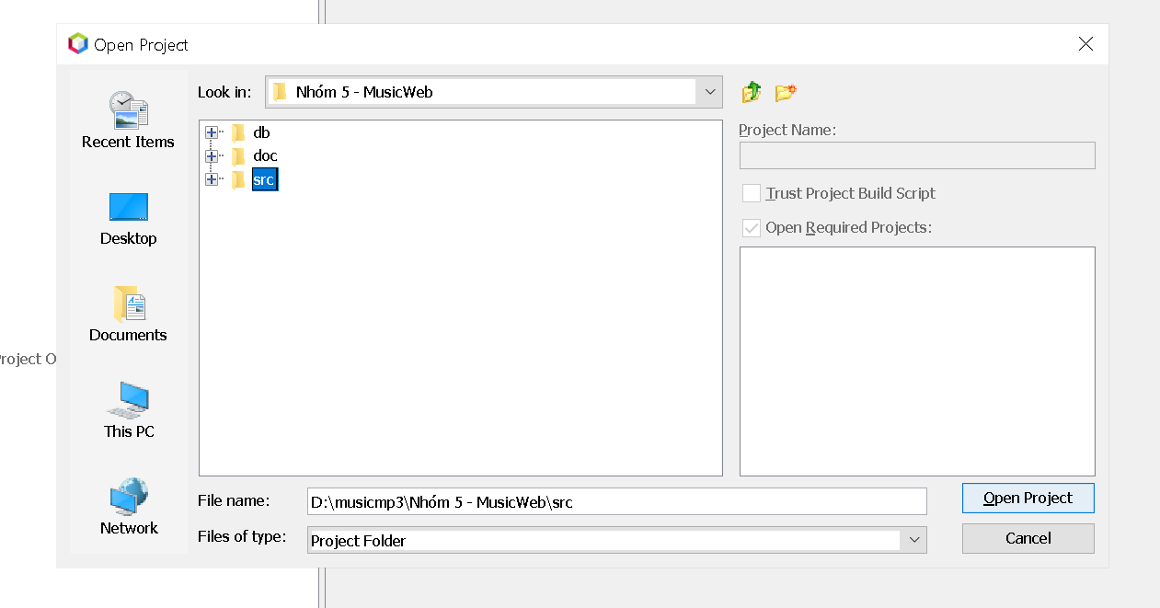

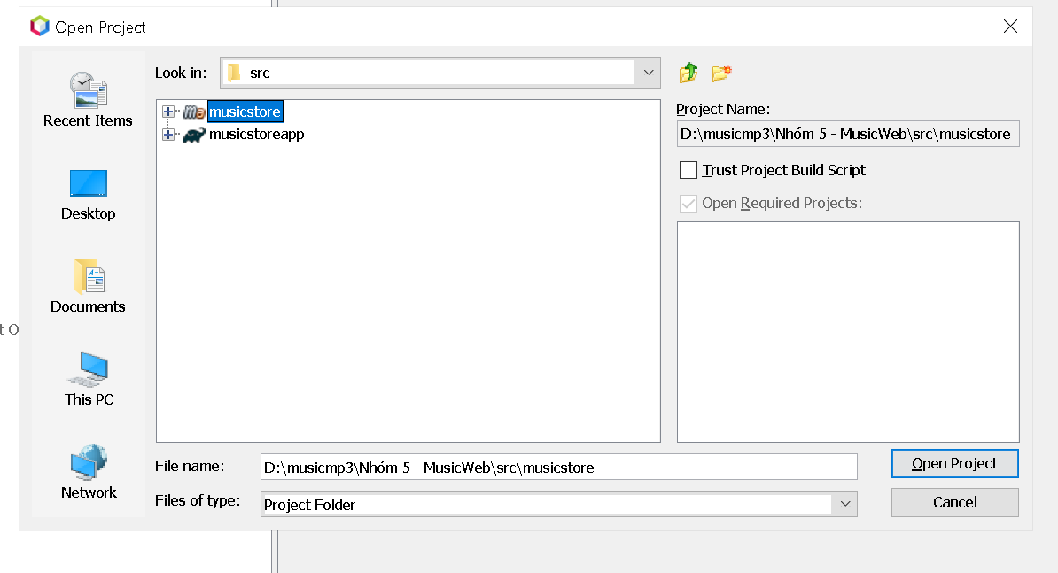

5.Your Website is on

Music Web On Android

1. Start your Android Studio

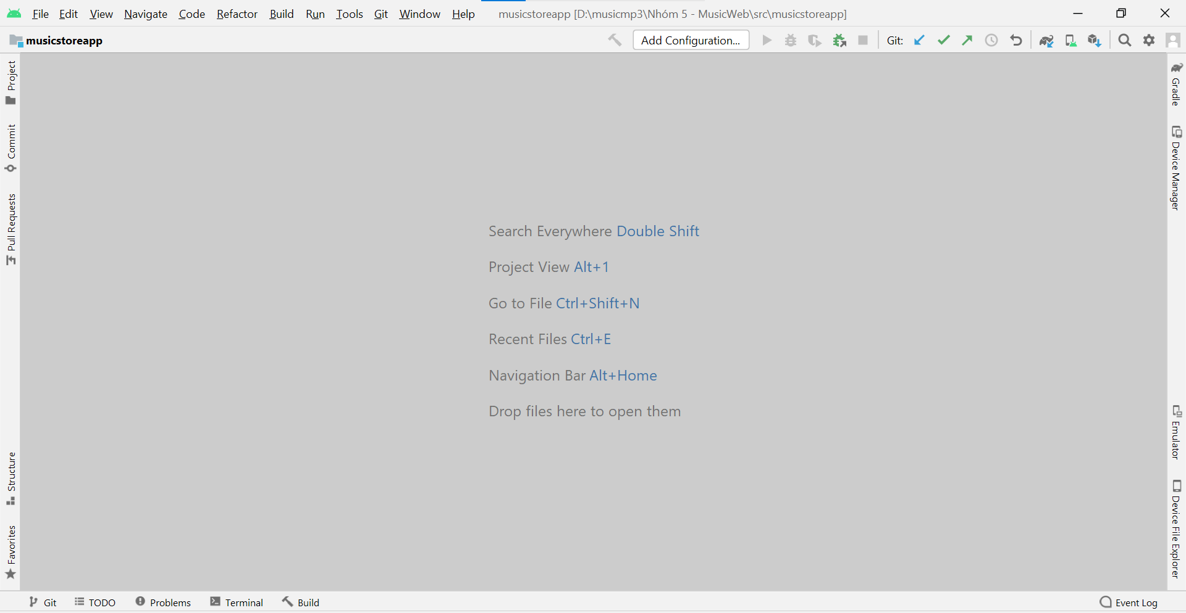

1. Open Project on Android Studio src folder

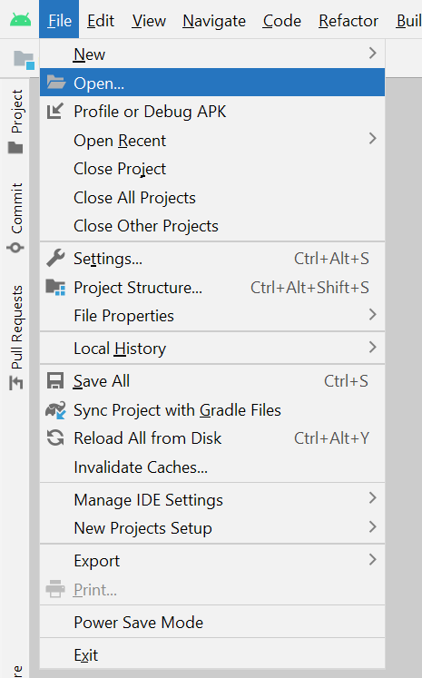

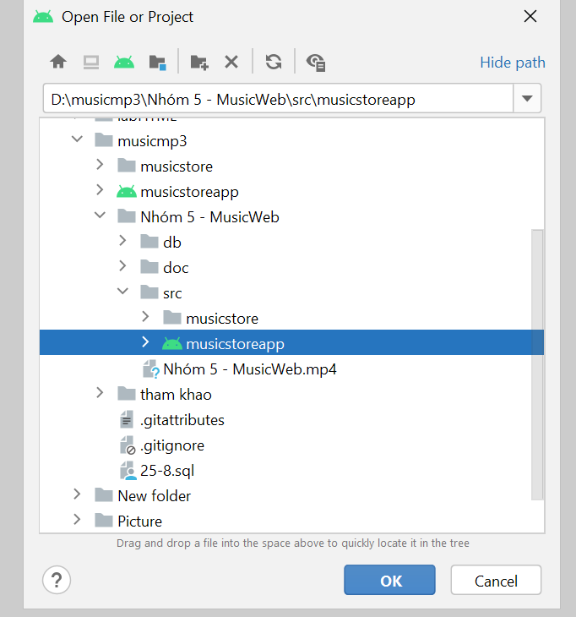

3.Then you open Command Prompt in your pc

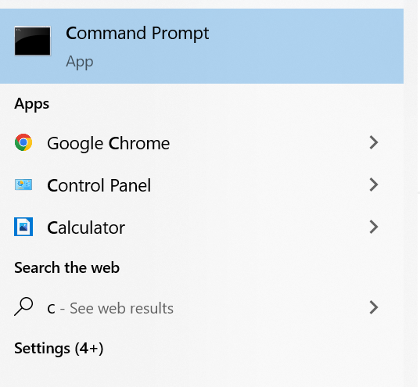

1. You input text “ipconfig” in Command Prompt to get your ip address

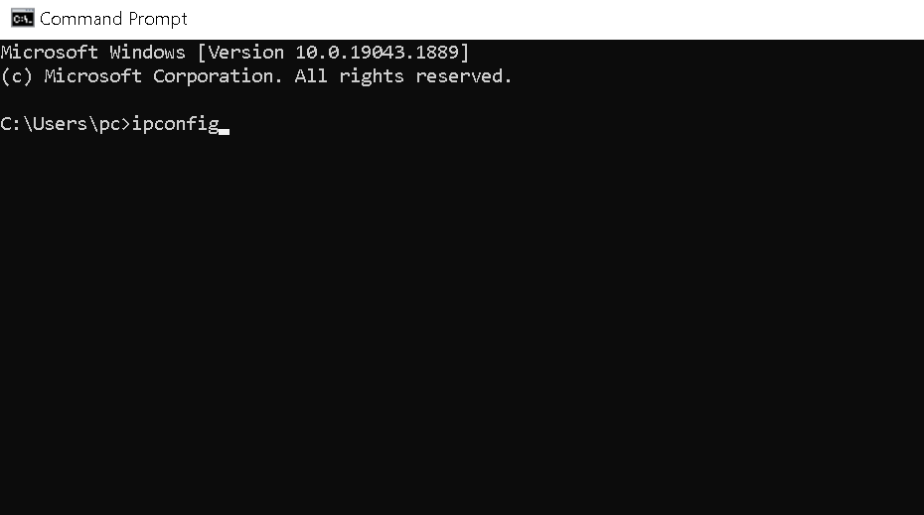

1. Copy your ip address

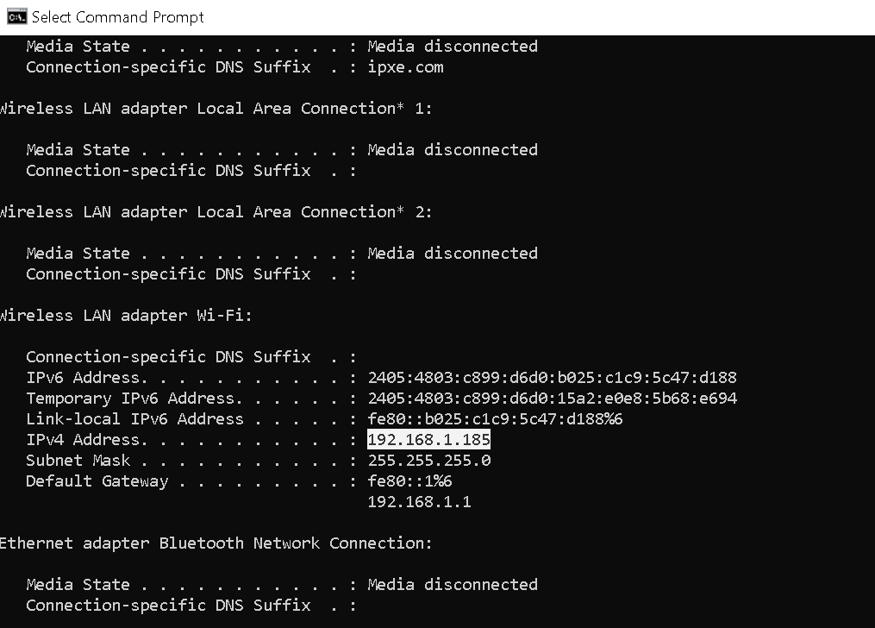

1. Back to Android Studio and go to app -> src-> main -> java ->

vn -> aptech ->musicstoreapp ->service_api -> api ->ApiUtil.java

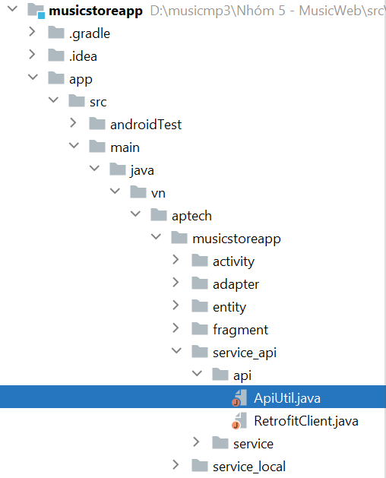

1. After that In ApiUtil.java you input your ip address you get in Commant Prompt in here

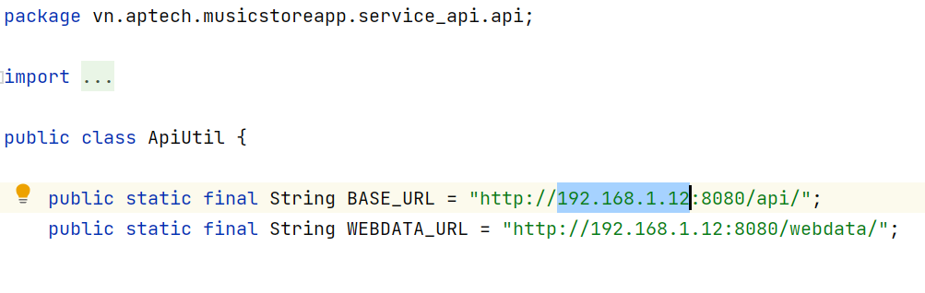

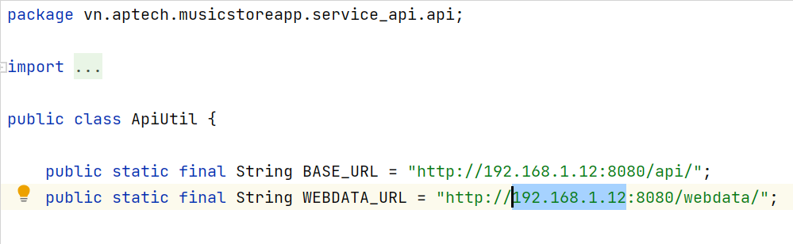

7.Your Android App is on